**SUPPLEMENTAL TEXT**

**Inference of gains and presence of genes on branches of the tree.**

To estimate the probability that specific genes were gained or present on each branch of the tree, we chose a simple heuristic, based on the joint probability of the states of the ancestor and descendant nodes (Methods). We chose this approach because we are not concerned with *any* gain, but rather with gains that are retained until the end of a branch. For example, any gain at all is to be expected at some rate more or less without regard to genome content of the host, due to phage infection or DNA in the environment. However, given that the vast majority of these gains are followed closely by losses (Baltrus 2013), they are not as biologically interesting as genes gained and retained adaptively, and they are also mostly unobserved. Additionally, our approach allows us to consider the probability of steady presence across a branch. We considered the average reconstruction at each node to compute the probability of gain or presence of genes on branches, rather than summing across each possible reconstructed scenario in the stochastic mapping procedure (for instance weighted by the likelihood of each possible scenario). While using all possible mappings could, in principle, reduce the numerical error of our probability estimates, it would entail an onerous and potentially intractable computation. Moreover, the biological (Figure 2) and statistical (Figure 5, Supplemental Figure S9) validations we have performed suggest that our results are robust.

Our method of inferring gains is also different from the probabilities of gains (or, similarly, the expected number of gains) that are computed by the *gainLoss* software (Cohen and Pupko 2010), using a previously-developed continuous-time Markov chain (CTMC) model to count the number of gains on each branch (Minin and Suchard 2008). These models solve the problem of counting the number of one-way transitions between two states (say, presence and absence) given transition rates, states at the start and end of the interval, and a set amount of time in the interval. Thus, the CTMC implemented in *gainLoss* is capable of estimating the expected number of gains of a given gene on a given branch, with knowledge of gain and loss rates. However, this approach can lead to problematic cases in which a gene can be absent in ancestor and descendant nodes, and yet, given a very long branch, is inferred to be gained on this branch. While such scenarios may have statistical support, in practice they are very hard to interpret and compare to other events that more obviously support a gain. Given the presence of Archaea in our phylogeny, which are a dramatically divergent outgroup, this was a cause for concern. Indeed, the CTMC estimated that the median gene was gained more than twice along the long branch connecting Archaea to Bacteria, with some genes gained more than 10 times on this branch alone (data not shown). This result is almost certainly artefactual, but has the potential to substantially skew the overall appraisal of gains for a given gene. For these reasons and those stated above, we chose to ignore the *gainLoss* CTMC estimates in favor of the less sophisticated but more interpretable gain/presence inference method described above and in Methods.

**Gain/loss ratio analysis.**

A consistent feature of prokaryotic genome evolution is the predominance of DNA loss over gain, or “deletional bias” (Mira et al. 2001; Kuo and Ochman 2009). One previous study, for example, found that the gain to loss ratio in prokaryotes varied widely across genomes, ranging approximately from 0.07 to 0.9, with most genomes exhibiting a ratio between 0.2 and 0.5. Accordingly, a reliable ancestral reconstruction and gain/loss inferences should exhibit an excess of gene losses relative to gene gains. The *gainLoss* program used in our study addresses this problem in part by setting prior distributions on gain and loss rates based on the average prevalence of genes in genomes at the tips of the tree, such that losses tend to dominate (Cohen and Pupko 2010). For our data, the mean of the rate prior distribution was 0.36 for gains and 1.38 for losses, corresponding to a 0.26 ratio, which is in line with previous estimates. These rates were then used in an iterative expectation-maximization model to infer ancestral genome reconstructions on the tree while optimizing these rates and other parameters. Following optimization, the corresponding rates for gains and losses were found to be 0.80 and 3.86, corresponding to an even stronger deletional bias of 0.20. After ancestral reconstruction and gain/loss inference by the heuristic outlined in Methods, we found that the mean number of gains for a gene along the tree was 13.9, whereas the corresponding mean number for losses was 24.9, suggesting a ratio of 0.56. The distribution of losses is also substantially right-shifted relative to gains (Supplemental Figure S1). Furthermore, gain and loss counts were significantly correlated (ρ = 0.75, p < 10-15; Pearson correlation test), indicating that frequently gained genes are also frequently lost. Combined, these finding suggest that our model indeed strongly penalizes losses, and that the actual gain to loss ratio reflects the expected excess of losses.

**Simulation of gene gain/loss evolution.**

Previous attempts to use the *gainLoss* software to make inferences about horizontal gene transfer and detect coevolution used a parametric bootstrapping approach, simulating the evolution of genes to obtain null expectations for testing hypotheses (Cohen et al. 2011, 2012). While the use of exact parametric methods to estimate this null distribution is possible in principle (Maddison 1990), these methods rely upon a single binary reconstruction of ancestral states. Clearly, our probabilistic reconstruction is unsuited for such an analysis. Again, one could in principle enumerate all possible reconstructions, and estimate the null distribution exactly as a weighted sum across each reconstructions, but developing this method for large trees lies outside the scope of this paper.

In our simulations, we therefore followed the example of others with certain modifications. The simulation procedure implemented in the *gainLoss* program was too memory-intensive to be feasible for a sufficiently large number of genes. Consequently, we took the gain and loss rates inferred by *gainLoss* for the real genes and used their distribution to simulate the evolution of genes using the function *rTraitDisc()* in the APE library. Briefly, we fit gamma distributions to the rates of gain and the rates of loss across all genes, and used the resulting parameters to define sampling distributions for gain and loss rates of simulated genes (see Methods). We then used the approach described in Methods to infer the probability of gain on each branch. We found that using these distributions inferred relatively few gains compared to the gains of observed genes (compare Supplemental Figure S2A and Supplemental Figure S2C). We speculated that the rate mixture model employed by *gainLoss* has difficulties accommodating the upper tail of the distribution of gain rates (roughly, those genes gained >50 times in this tree), given that the vast majority of genes are gained relatively few times (Supplemental Figure S2A). Consequently, we adjusted the shape parameters of the gain and loss rate distributions heuristically to find values that gave distributions of simulated gains that included genes that are gained sufficiently many times. We found that multiplying the shape parameter of the gain rate by 3 and the shape parameter of the loss rate by 1.5 gave reasonably wide distributions of gains among simulated genes (Supplemental Figure S2E). It is important to note that the shape of the distribution from which rates are drawn does not affect the simulated evolution of a given gene with single sampled gain and loss rates. Furthermore, because we are not using the entire distribution of simulated genes but only those most appropriate to each gene as a null distribution, any differences in the distributions of gain counts between simulated and real genes are unlikely to affect results.

**Robustness of gain events inference to analytic method.**

To assess the robustness of our gain inference approach, we set out to compare the gain events inferred by our stochastic mapping-based methodto horizontally transferred genes inferred by a reconciliation-based method (Jeong et al. 2015). While these two methods are likely to yield somewhat different results, we wished to confirm that they still agree on a substantial fraction of the inferred gain events (Ravenhall et al. 2015). To this end, we used a recently published database of horizontally transferred genes inferred by a well-established sequence-based reconciliation tool (Jeong et al. 2015). Since this database provides information on horizontally transferred genes detected in extant species, we specifically examined whether the genomes of extant species that are descendants of a branch on which a specific gene was inferred to be gained by our method were indeed more likely to be identified as having acquired this gene by HGT according to reconciliation. Notably, since data in the HGT database was not readily accessible, we limited our comparison to a small number of key genes (including, for example, *rbsS,* the RuBisCO small subunit discussed in our paper; and see Supplemental Table S1). Indeed, we found that extant species that are descendants of the 8 *rbsS* gain events inferred by our method were significantly more likely to have this gene identified as horizontally transferred compared to other species (24 out of 31 vs. 30 out of 2441 for descendants vs. not descendants respectively; odds ratio = 275.5, p < 10-32, Fisher’s exact test). Moreover, of the 8 *rbsS* gain events, in 6 cases at least one descendant had this gene identified as horizontally transferred by reconciliation, suggesting that the high odds-ratio above is not simply the outcome of just one or two gain events with numerous descendants (and in fact, in these 6 cases *all* descendants had the gene identified by reconciliation). This extremely strong association between gains inferred by the two methods points to a high level of agreement between the two approaches. Analyzing several additional genes with many associated PGCEs revealed overall high levels of agreement between the two methods (Supplemental Table S1). One apparent exception was the *kpsT* gene, which showed relatively low agreement between our method and reconciliation. Interestingly, however, we found substantial evidence of acquisition of other components of the *kps* operon for most *kpsT* gains predicted by stochastic mapping (in particular *kpsM*, which is immediately adjacent to *kpsT* in the *kps* operon). This operon has been gained by HGT in various pathogenic *E. coli* (Schneider et al. 2004), as found also by stochastic mapping.

**Power of the PGCE detection method.**

One of our observations is that there are weak relationships between the prevalence of a gene, how often it is gained, and its in- and out-degrees in the PGCE network (Supplemental Figure S5). Given that these values define the null distributions that we use to infer PGCEs, it was possible that our analyses are less sensitive for certain values of these parameters. We considered to what extent a lack of power was affecting our results with a simple power analysis. For genes *i* and *j*, the maximum observable value *Cij* counting the gains of *j* in the presence of *i* is min(*pi*, *gj*), representing respectively the prevalence of gene *i* and the number of gains of gene *j*. For a range of values of these parameters (*pi*, *gj*), we compared this maximum potential observation to the null distribution from parametric bootstrapping appropriate to these parameter values. This represents the most extreme possible test statistic between the two genes for these parameter values, so in each case the null hypothesis should be rejected if there is sufficient power. We found that power varied substantially across various values of (*pi*, *gj*) (Supplemental Figure S3A). Specifically, we were incapable of detecting associations for any combination involving the most-prevalent genes or the least-gained genes. This is unsurprising, given that noise is expected to be high for the former, and signal to be low for the latter. Considering our observed distribution of p-values (Supplemental Figure S3B), we find the expected spike in frequency near p = 0 (indicating true positive dependencies), but also an unexpected spike in frequency near p = 1, indicating that our parametric bootstrapping test is underpowered due to the sparsity of gains, as suggested by power analysis (Supplemental Figure S3A). Consequently, there are likely to be many more PGCEs than we detect in this study. Notably, if we relax our FDR threshold from 1% to 5% in inferring PGCEs, we increase the raw number of edges in our network more than ten-fold (from 8,415 to 86,719). We chose to proceed with the more stringent threshold to focus on the most confident PGCEs, but we use this example to highlight the very large potential for PGCEs structuring genome evolution in prokaryotes.

**Processing and analysis of the PGCE network.**

After inferring a PGCE network, we post-processed this network to both ease further analysis and to remove potentially spurious edges. First, we removed edges such that the network became a directed acyclic graph (DAG). DAGs are relatively easy to analyze and interpret topologically. We found only one cycle-inducing edge: an obviously spurious self-edge (for gene K07218). The absence of non-spurious cycles may be initially surprising, but can be explained by the relatively small number of genes with in-edges (less than one-third of genes in the network) and the anti-correlation of in-degree and out-degree across genes (Supplemental Figure S5E). To evaluate whether the lack of cycles is attributable to degree distribution, we randomly rewired the DAG five times while preserving degree distribution, and in each of these five cases the result was still a DAG. This analysis indicates that this acyclic topology is a simple consequence of degree distribution, rather than a biological property of specific PGCE relationships. Together, these results indicate that few cycles are expected for a network with such properties. However, one might still expect some number of true cycles from a biological point of view, even if the network itself is biased against them. We believe that such cycles likely exist, but we do not detect them because of our relatively low power, and the stringency of our threshold for assigning edges (Supplemental Figure S3, see above section).

Next, we removed potentially spurious edges in the network that might have been introduced by indirect transitive effects. For example, if gene A encourages the gain of gene B, and gene B encourages the gain of gene C (A🡪B🡪C), we might also infer that there is a direct A🡪C PGCE, even if such a PGCE does not actually exist. Consequently, we performed a transitive reduction of our DAG to obtain a “minimal equivalent graph” (Hsu 1975), or a DAG with all potentially indirect interactions (such as the A🡪C example above) removed. While potentially removing true PGCEs, we thus enrich our PGCE network for the most confident interactions. This procedure removed 186 potentially indirect PGCEs. It is this DAG, with all cycles and indirect edges removed, that we used for all downstream analyses.

The degree distributions for this network indicated that a slight majority of genes (nodes) are disconnected, and we omitted these genes from further analyses. Furthermore, the distribution of in-degrees was more unequal than that of out-degrees across nodes (Supplemental Figure S5A, S5B). The degree distributions showed weak relationships with the prevalence and gain count of genes, but these do not appear to be primary determinants of network structure (Supplemental Figure S5C, S5D).

**Dependencies among pathways.**

The *urtA-rbsL* PGCE (Figure 3B) highlighted the potential importance of inter-pathway PGCE dependencies. To understand the structure of such pathway-pathway dependencies, we tested for associations between genetic pathways within the PGCE network, compared to a null distribution of rewired networks. We detected 93 pathway-pathway dependencies (each p < 0.001, compared to the rewired null distribution), which we modeled as a directed network among 65 pathways (Supplemental Figure S6). Unlike the PGCE network, the pathway-pathway dependency network has many cycles. Related pathways showed many dependencies and clustered with each other, most strikingly for the metabolism of aromatic compounds. Consequently, we expect that PGCE dependencies, rather than only representing one-to-one interactions between genes, also reflect functional relationships between whole genetic pathways.

**Algorithms.**

*Feedback arc set (FAS) identification algorithm*(Hausmann and Korte 1978; Hassin and Rubinstein 1994)**.**

1. Start with an empty DAG and an empty FAS;
2. Select a random edge *E* from our PGCE network, add it to the DAG;
3. If adding *E* to the graph adds a cycle, remove *E* again and add it to the FAS, else accept *E* in the DAG;
4. If there are more edges that are neither in the DAG nor in the FAS, go to 2

*Transitive reduction of a DAG algorithm*(Hsu 1975)**.**

1. Convert the network into an adjacency matrix representation;
2. Convert the adjacency matrix into a path matrix;
3. Remove all edges in the path matrix that can be explained by other paths, by iterating over all groups of 3 nodes.

*Topological sort with grouping algorithm* (Knuth 1973)**.**

We used the following procedure to perform a topological sort of a DAG:

1. Initialize the rank count with “rank” = 1;
2. Identify the set of nodes in the DAG with in-degree = 0 (these occupy the first position in a sort);
3. Label these nodes with the current “rank” (1 in the first step);
4. Remove these nodes and their edges from the DAG (some new nodes will now have in-degree = 0;
5. if there are still nodes in the DAG, increment “rank” by 1 and go to step 2.

The resulting labeled groups constitute the ordered ranks of the topological sort.

***gainLoss* program parameters**

The following are the *gainLoss* parameters used to generate the principal data reported in the paper. We omitted several parameters (e.g., paths to files) to reduce confusion, but the complete parameter file can be found as Supplemental File S2.

_printPij_t 1

_printL_of_Pos 1

_calculateAncestralReconstruct 1

_printAncestralReconstructFullData 1

_printExpPerPosPerBranchMatrix 1

_printTree 1

_optimizationLevel mid

_rateDistributionType GAMMA

_performOptimizationsBBL 1

_performOptimizations 1

_numberOfGainCategories 3

_numberOfLossCategories 3

_numberOfRateCategories 3

_maxNumOfIterationsManyStarts 3

_calculateRate4site 1

_calculeGainLoss4site 1

_gainLossDist 1

_calculeGainLoss4site 1

_printLikelihoodLandscapeGainLoss 1

_printPij_t 1

**SUPPLEMENTAL FILES**

**Supplemental File S1:** Final PGCE dependency network (.xlsx file).

**Supplemental File S2:** Parameter file for principal *gainLoss* run (.txt file).

**Supplemental File S3:** Log file for principal *gainLoss* run (.txt file).

**Supplemental File S4:** Code and data for analysis (.zip archive).

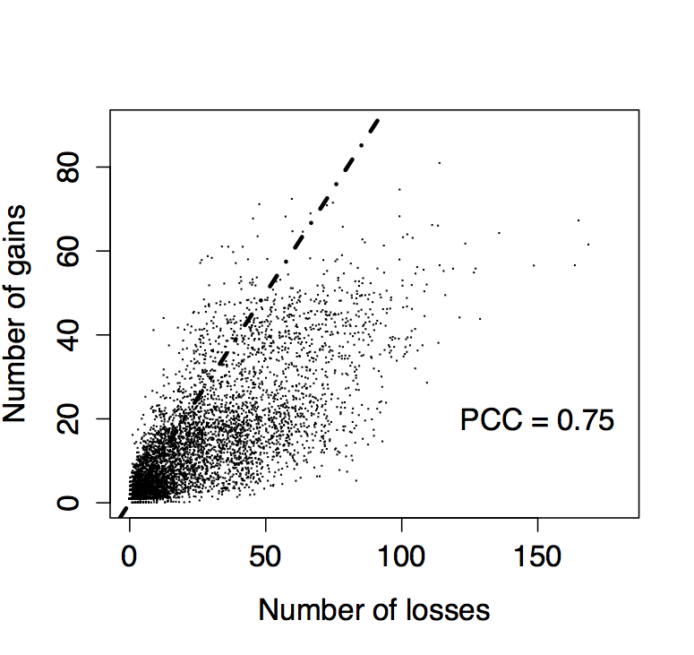

**Figure S1. Gene losses outnumber gene gains.** Each of the 5801 genes in the ancestral reconstruction is plotted according to its number of losses and gains. Dashed line indicates expected values if gains and losses were equally frequent. “Gain” and “loss” counts represent the expected number of branches experiencing gain and loss, respectively, for the gene in question. PCC: Pearson correlation coefficient.

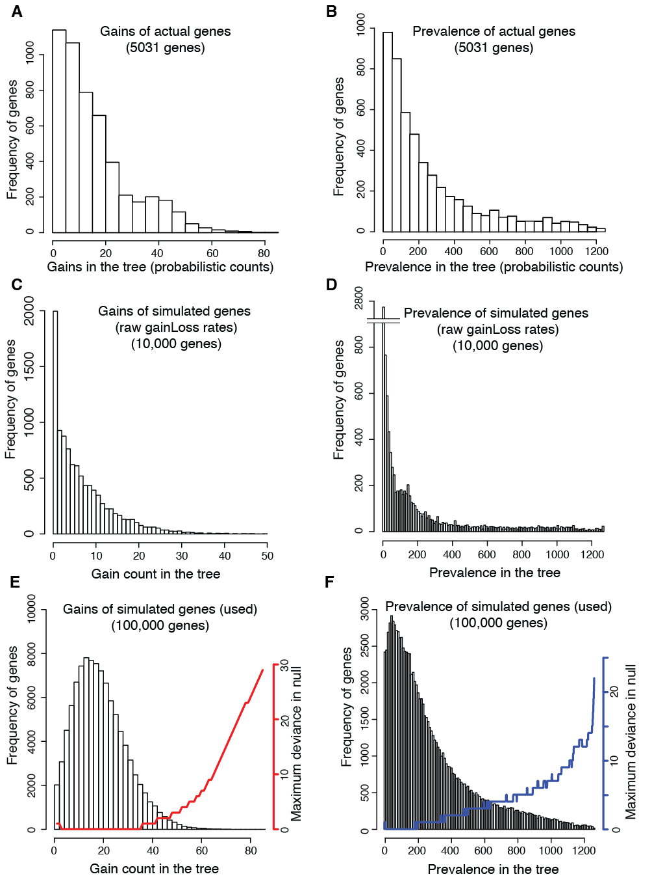

**Figure S2. Comparison of evolution of real genes with genes with simulated evolution under various models.** Distributions of total gains (A) and prevalence (B) estimated for real genes by the *gainLoss* program. *gainLoss* rate estimates lead to underestimation of gains (C) and prevalence (D) in the tree: gene gain counts across 104 genes simulated according to gain/loss rates directly estimated by *gainLoss* for empirical genes. Gene gain (E) and prevalence (F) counts across genes simulated for use in null distributions. Red (gain) and blue (prevalence) line plots indicate, for each value of gain count or prevalence, the absolute difference of the least similar gene in its null distribution from that value (maximum deviance). For instance, in (E), a gene with 40 gains will be compared to a null distribution of simulated genes with as few as 39 gains and as many as 41 gains (deviance of one). Relative to (A) and (B), parameters of the underlying distributions of gain and loss rates were heuristically adjusted to provide acceptable coverage of the gain/prevalence values observed for empirical genes in (E) and (F).



**Figure S3.** **Some regions of the parameter space are underpowered to detect PGCEs.** (A) Power analysis of the parametric bootstrapping hypothesis test for detecting PGCEs. X and Y axes represent, respectively, total prevalence and total gains for a hypothetical pair of genes with a strong PGCE (maximum observable test statistic). Colors represent the (log10-scaled) minimum possible p-value that can be attained for such a gene pair using the relevant null distribution of simulated genes. Areas that are not white/pale yellow are underpowered for detecting PGCEs. (B) The distribution of empirical p-values observed for testing hypotheses of no PGCE in the evolution of pairs of genes, according to parametric bootstrapping. The spike at p = 1.0 in (B) indicates that sparsity in the data detracts from power, as predicted in (A), even after filtering pairs of genes with Cij <= 1.



**Figure S4. A global network of directional dependencies between prokaryotic genes (PGCEs).** Node size is scaled to total edge count for each node (and see also Supplemental Figure S5).



**Figure S5.** **Topological characteristics of the PGCE network.** (A) Out-degree distributions of the final PGCE network (nodes with out-degree equal to zero are omitted). (B) In-degree distributions of the final PGCE network (nodes with in-degree equal to zero are omitted). (C-E): Prevalence and gain counts of genes only weakly affect their PGCEs. The degrees of each gene (node) in the PGCE network are plotted against its prevalence (C) and counted gains (D) throughout the tree, and the degrees are plotted against each other (E). Pearson correlations between the plotted variables are indicated above each plot. PCC = Pearson correlation coefficient, p-value is from a correlation test.



**Figure S6. A network of evolutionary dependencies between functional pathways.** Overall structure of the evolutionary pathway-pathway dependency network. Directed edges indicate that the source pathway and the sink pathway are connected by more PGCEs between individual genes in those pathways than expected from a rewired null distribution (p < 0.001). Colors indicate selected pathway clusters of similar functions (green: aromatic compound secondary metabolism; red: pathogenesis; purple: carbohydrate metabolism; yellow: DNA metabolism).

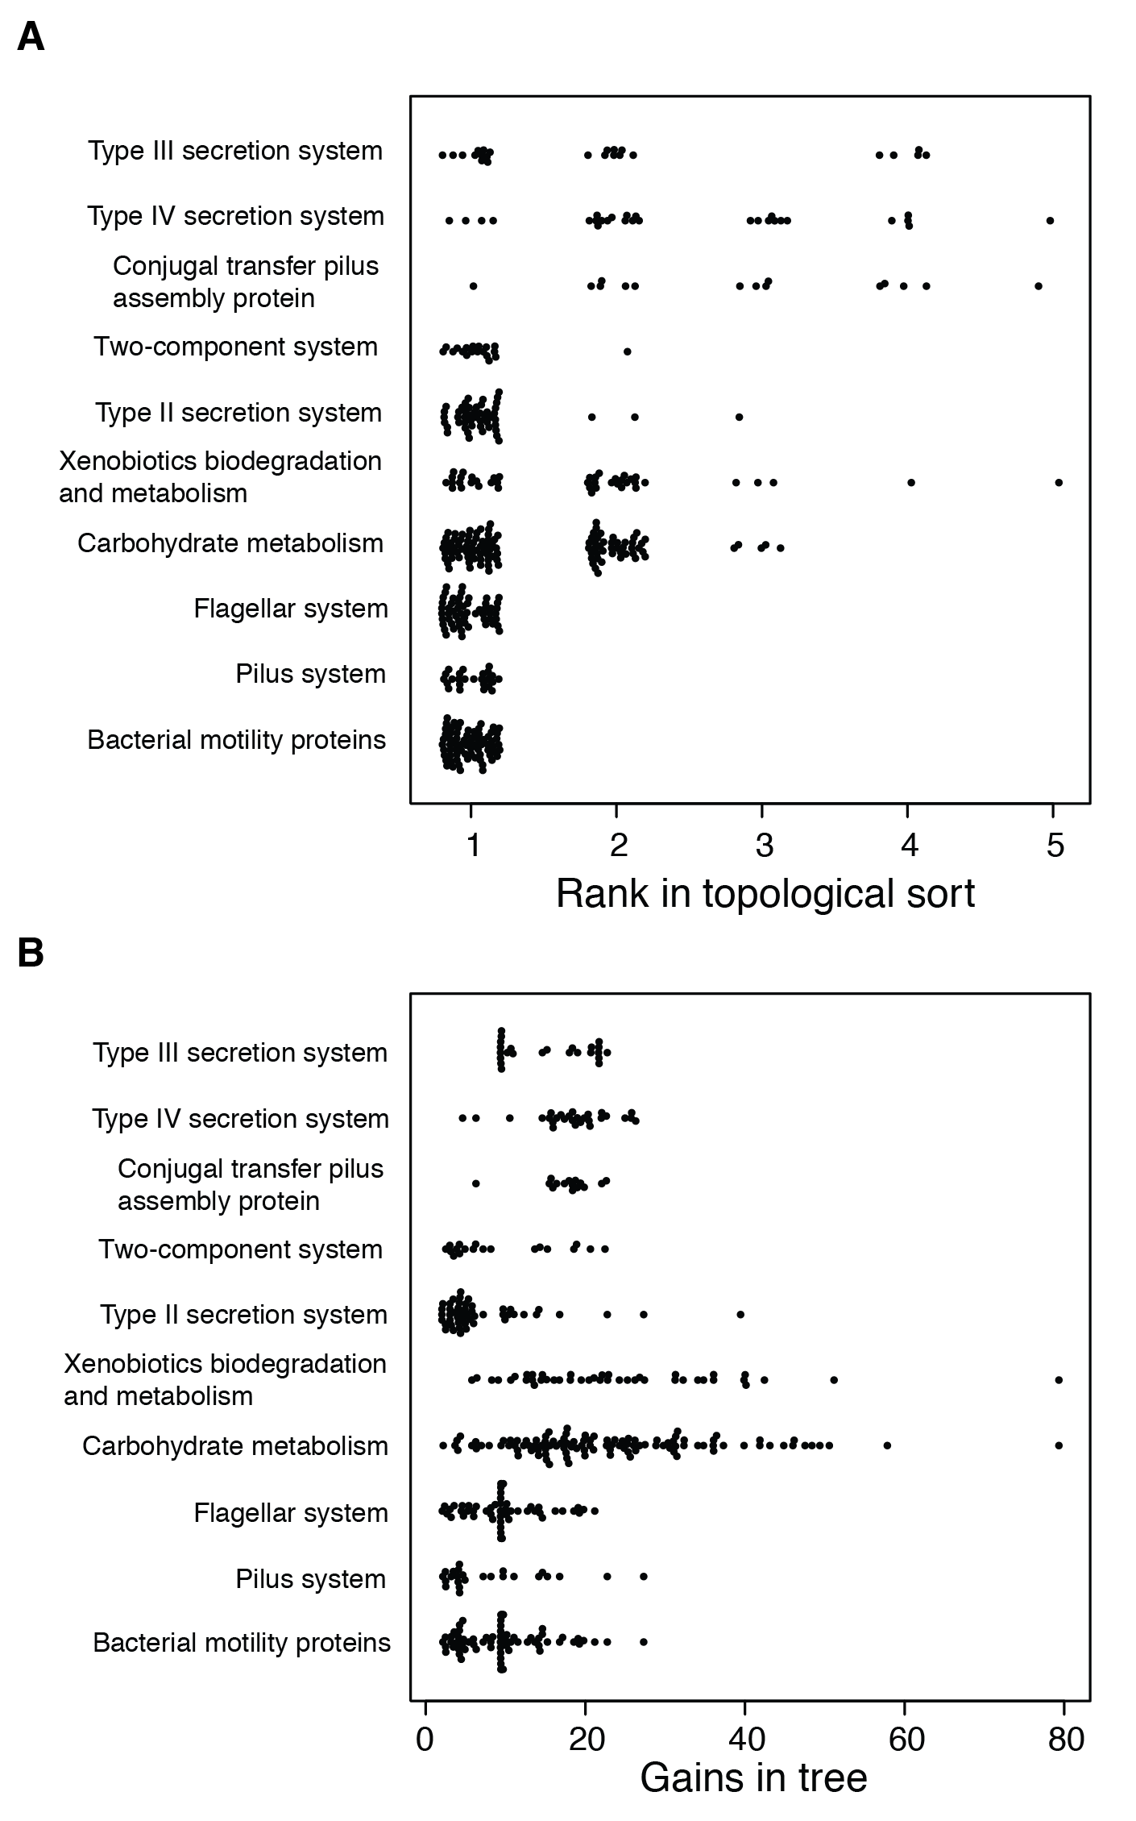

**Figure S7. Differences in gain counts do not explain differential sorting of genes in different functional groups.** (A): Variation in ranks of the sort across functional categories. (B): Total branches in which gains have occurred (“gains in tree”) across genes in various functional categories that are differentially ranked in a topological sort of the PGCE network. Note that the categories with the highest average gain (Carbohydrate and Xenobiotics metabolism) are ranked in the middle of the sort. See Table 1.



**Figure S8. Phylogenetic depth of gene gains in bacteria decreases with rank in the topological sort.** Phylogenetic depth of the gains of genes are weakly negatively correlated with their ranks in the sort (Spearman’s r = -0.24, p < 10-15). For each rank, we plot the distribution of the phylogenetic depths (distance of gain branch from root) of the average depth of confident gains (Pr(gain) > 0.6) of each gene in that rank. The mean of each distribution is plotted as a red point. Branches leading to Archaea and archaeal genomes are omitted from the analysis. Boxplot widths are scaled to the number of genes in each rank of the sort. The tree was converted to an ultrametric tree for the purpose of this analysis (the root is separated from all tips by a total branch length of 1.0).



**Figure S9. Performance of models for predicting the acquisition of genes between clades.** (A) Overlap of edges in PGCE networks inferred from different subsets of the data. See also Supplemental Table S4. All overlaps are highly statistically significant (p < 10-15, hypergeometric test). (B) Distribution of prediction scores for gene acquisition on each branch in the test set clades. Branches with a gain (Pr(gain) > 0.5)) have a higher score than branches without a gain (Pr(gain) < 0.5) for predictable genes (p < 10-15 for each, U-test). Predictable genes are the affected genes in at least one PGCE, i.e. they have at least one in-edge in the trained PGCE model. Violin plots show density of each distribution, with an inset boxplot (white box is median of distribution). Each violin plot shows the distribution of prediction scores for branches in one test set for one category (gene gained/gene not gained). (C) A precision/recall plot of PGCE predictions. Notably, the precision by which any particular gain event is predicted is relatively low due to the rarity of true gain events for any particular gene, yet, as demonstrated in Figure 5B and in panel B here, ancestral genome content was overall very informative about where along the tree such true gain events will actually occur.

**Table S1.** Reconciliation analysis supports gene acquisitions inferred by stochastic mapping*.*

|  |  |  |  |  |  |  |  |  |
| --- | --- | --- | --- | --- | --- | --- | --- | --- |
| Gene (KEGG Orthology) | Predicted gains1 | Supported gains2 | Descendants with HGT3 | Descendants w/o HGT4 | Not descendants with HGT5 | Not descendants w/o HGT6 | Odds ratio | P-val |
| *rbsS* (K01602) | 8 | 6 | 24 | 7 | 30 | 2411 | 275.5 | < 10-32 |
| *napE* (K02571) | 4 | 3 | 4 | 2 | 102 | 2364 | 46.4 | < 10-4 |
| *parA* (K12055) | 10 | 8 | 21 | 4 | 570 | 1877 | 17.3 | < 10-6 |
| *sctD* (K03200) | 8 | 4 | 9 | 7 | 90 | 2366 | 33.8 | < 10-11 |
| *kpsT* (K09689) | 16 | 2 | 2 | 30 | 174 | 2266 | 0.87 | 1.00 |

1: Number of branches where a gain event was inferred for this gene by our stochastic mapping-based approach.

2: Number of gain events predicted by our stochastic mapping-based approach for which at least one descendant had this gene identified as horizontally transferred by reconciliation.

3: Number of genomes (out of 2472) that are descendants of a stochastic mapping-based gain event and have this gene identified as horizontally transferred by reconciliation.

4: Number of genomes (out of 2472) that are descendants of a stochastic mapping-based gain event but do not have this gene identified as horizontally transferred by reconciliation.

5: Number of genomes (out of 2472) that are not descendants of a stochastic mapping-based gain event but have this gene identified as horizontally transferred by reconciliation.

6: Number of genomes (out of 2472) that are not descendants of a stochastic mapping-based gain event and do not have this gene identified as horizontally transferred by reconciliation.

**Table S2.** Genes which influence the gain of *rbsS*, gene encoding the RuBisCO small chain.

|  |  |
| --- | --- |
| **KEGG Orthology (KO)** | **Description** |
| K02584 | Nif-specific regulatory protein |
| K06139 | pyrroloquinoline quinone biosynthesis protein E |
| K06138 | pyrroloquinoline quinone biosynthesis protein D |
| K06137 | pyrroloquinoline-quinone synthase [EC:1.3.3.11] |
| K06136 | pyrroloquinoline quinone biosynthesis protein B |
| K09165 | hypothetical protein |
| K03809 | Trp repressor binding protein |
| K13483 | xanthine dehydrogenase YagT iron-sulfur-binding subunit |
| K13481 | xanthine dehydrogenase small subunit [EC:1.17.1.4] |
| K02448 | nitric oxide reductase NorD protein |
| K02597 | nitrogen fixation protein NifZ |
| K02596 | nitrogen fixation protein NifX |
| K02595 | nitrogenase-stabilizing/protective protein |
| K02593 | nitrogen fixation protein NifT |
| K02592 | nitrogenase molybdenum-iron protein NifN |
| K02022 | HlyD family secretion protein |
| K11811 | arsenical resistance protein ArsH |
| K08973 | putative membrane protein |
| K12511 | tight adherence protein C |
| K08995 | putative membrane protein |
| K07506 | AraC family transcriptional regulator |
| K10778 | AraC family transcriptional regulator, regulatory protein of adaptative response / methylated-DNA-[protein]-cysteine methyltransferase [EC:2.1.1.63] |
| K07165 | transmembrane sensor |
| K07161 | NA |
| K00830 | alanine-glyoxylate transaminase / serine-glyoxylate transaminase / serine-pyruvate transaminase [EC:2.6.1.44 2.6.1.45 2.6.1.51] |
| K01266 | D-aminopeptidase [EC:3.4.11.19] |
| K05559 | multicomponent K+:H+ antiporter subunit A |
| K02278 | prepilin peptidase CpaA [EC:3.4.23.43] |
| K02279 | pilus assembly protein CpaB |
| K02276 | cytochrome c oxidase subunit III [EC:1.9.3.1] |
| K02274 | cytochrome c oxidase subunit I [EC:1.9.3.1] |
| K02275 | cytochrome c oxidase subunit II [EC:1.9.3.1] |
| K02305 | nitric oxide reductase subunit C |
| K13924 | two-component system, chemotaxis family, CheB/CheR fusion protein [EC:2.1.1.80 3.1.1.61] |
| K13926 | ribosome-dependent ATPase |
| K09924 | hypothetical protein |
| K10764 | O-succinylhomoserine sulfhydrylase [EC:2.5.1.-] |
| K07157 | NA |
| K03188 | urease accessory protein |
| K01067 | acetyl-CoA hydrolase [EC:3.1.2.1] |
| K01797 | NA |
| K00824 | D-alanine transaminase [EC:2.6.1.21] |
| K00685 | arginine-tRNA-protein transferase [EC:2.3.2.8] |
| K09796 | hypothetical protein |
| K11177 | xanthine dehydrogenase YagR molybdenum-binding subunit [EC:1.17.1.4] |
| K11178 | xanthine dehydrogenase YagS FAD-binding subunit [EC:1.17.1.4] |
| K00329 | NADH dehydrogenase [EC:1.6.5.3] |
| K09008 | hypothetical protein |
| K09005 | hypothetical protein |
| K05563 | multicomponent K+:H+ antiporter subunit F |
| K01800 | maleylacetoacetate isomerase [EC:5.2.1.2] |
| K00253 | isovaleryl-CoA dehydrogenase [EC:1.3.8.4] |
| K02258 | cytochrome c oxidase assembly protein subunit 11 |
| K11962 | urea transport system ATP-binding protein |
| K11963 | urea transport system ATP-binding protein |
| K11960 | urea transport system permease protein |
| K11961 | urea transport system permease protein |
| K05973 | poly(3-hydroxybutyrate) depolymerase [EC:3.1.1.75] |
| K07102 | NA |
| K00023 | acetoacetyl-CoA reductase [EC:1.1.1.36] |
| K15866 | 2-(1,2-epoxy-1,2-dihydrophenyl)acetyl-CoA isomerase [EC:5.3.3.18] |
| K04561 | nitric oxide reductase subunit B [EC:1.7.2.5] |
| K05564 | multicomponent K+:H+ antiporter subunit G |
| K05562 | multicomponent K+:H+ antiporter subunit E |
| K05561 | multicomponent K+:H+ antiporter subunit D |
| K05560 | multicomponent K+:H+ antiporter subunit C |
| K02533 | tRNA/rRNA methyltransferase [EC:2.1.1.-] |
| K15011 | two-component system, sensor histidine kinase RegB [EC:2.7.13.3] |
| K03200 | type IV secretion system protein VirB5 |
| K07303 | isoquinoline 1-oxidoreductase, beta subunit [EC:1.3.99.16] |
| K07302 | isoquinoline 1-oxidoreductase, alpha subunit [EC:1.3.99.16] |
| K07234 | uncharacterized protein involved in response to NO |
| K00303 | sarcosine oxidase, subunit beta [EC:1.5.3.1] |
| K02651 | pilus assembly protein Flp/PilA |
| K01055 | 3-oxoadipate enol-lactonase [EC:3.1.1.24] |
| K02502 | ATP phosphoribosyltransferase regulatory subunit |
| K03325 | arsenite transporter, ACR3 family |
| K02225 | cobalamin biosynthetic protein CobC |
| K01991 | polysaccharide export outer membrane protein |
| K04748 | nitric oxide reductase NorQ protein |
| K00304 | sarcosine oxidase, subunit delta [EC:1.5.3.1] |
| K00305 | sarcosine oxidase, subunit gamma [EC:1.5.3.1] |
| K01429 | urease subunit beta [EC:3.5.1.5] |
| K05343 | maltose alpha-D-glucosyltransferase/ alpha-amylase [EC:5.4.99.16 3.2.1.1] |
| K06044 | (1->4)-alpha-D-glucan 1-alpha-D-glucosylmutase [EC:5.4.99.15] |
| K13766 | methylglutaconyl-CoA hydratase [EC:4.2.1.18] |
| K01430 | urease subunit gamma [EC:3.5.1.5] |
| K11959 | urea transport system substrate-binding protein |
| K15012 | two-component system, response regulator RegA |
| K00457 | 4-hydroxyphenylpyruvate dioxygenase [EC:1.13.11.27] |
| K00104 | glycolate oxidase [EC:1.1.3.15] |
| K04756 | alkyl hydroperoxide reductase subunit D |
| K03519 | carbon-monoxide dehydrogenase medium subunit [EC:1.2.99.2] |
| K09983 | hypothetical protein |
| K06995 | NA |
| K00119 | NA |
| K00449 | protocatechuate 3,4-dioxygenase, beta subunit [EC:1.13.11.3] |
| K00114 | alcohol dehydrogenase (cytochrome c) [EC:1.1.2.8] |
| K05524 | ferredoxin |
| K02282 | pilus assembly protein CpaE |
| K02280 | pilus assembly protein CpaC |
| K03153 | glycine oxidase [EC:1.4.3.19] |
| K09959 | hypothetical protein |
| K00050 | hydroxypyruvate reductase [EC:1.1.1.81] |
| K08738 | cytochrome c |
| K07018 | NA |
| K00126 | formate dehydrogenase, delta subunit [EC:1.2.1.2] |
| K14161 | protein ImuB |
| K11902 | type VI secretion system protein ImpA |
| K07246 | tartrate dehydrogenase/decarboxylase / D-malate dehydrogenase [EC:1.1.1.93 4.1.1.73 1.1.1.83] |
| K03198 | type IV secretion system protein VirB3 |
| K11472 | glycolate oxidase FAD binding subunit |
| K11473 | glycolate oxidase iron-sulfur subunit |
| K11475 | GntR family transcriptional regulator, vanillate catabolism transcriptional regulator |
| K07649 | two-component system, OmpR family, sensor histidine kinase TctE [EC:2.7.13.3] |
| K07395 | putative proteasome-type protease |
| K07028 | NA |
| K02391 | flagellar basal-body rod protein FlgF |
| K01601 | ribulose-bisphosphate carboxylase large chain [EC:4.1.1.39] |
| K03821 | polyhydroxyalkanoate synthase [EC:2.3.1.-] |
| K07168 | CBS domain-containing membrane protein |
| K06923 | NA |
| K00411 | ubiquinol-cytochrome c reductase iron-sulfur subunit [EC:1.10.2.2] |
| K01941 | urea carboxylase [EC:6.3.4.6] |
| K17226 | sulfur-oxidizing protein SoxY |
| K11897 | type VI secretion system protein ImpF |
| K10125 | two-component system, NtrC family, C4-dicarboxylate transport sensor histidine kinase DctB [EC:2.7.13.3] |
| K10126 | two-component system, NtrC family, C4-dicarboxylate transport response regulator DctD |
| K04090 | indolepyruvate ferredoxin oxidoreductase [EC:1.2.7.8] |

**Table S3.** Enrichment analysis of genes influencing the gain of *rbsS*.

|  |  |  |  |  |
| --- | --- | --- | --- | --- |
| **Annotation label** | **p-value1** | **test set2** | **background set3** | **Enrichment4** |
| Nitric oxide reductase (Nor) complex | 6.73E-05 | 4 | 5 | 12.83018868 |
| Urea transport system (Urt) | 8.62E-07 | 5 | 5 | 16.03773585 |
| Purine degradation, xanthine=>urea | 0.00042 | 4 | 7 | 9.164420485 |
| Photorespiration | 8.49E-05 | 5 | 9 | 8.909853249 |
| Type IV secretion system | 0.0031 | 4 | 11 | 5.831903945 |

1: from a hypergeometric test.

2: the number of genes with this annotation appearing in Supplemental Table S1 (out of 88 genes).

3: the number of genes with this annotation appearing in the set of all genes in the PGCE network (out of 2472 genes).

4: The ratio of the observed proportion of genes with this label to the expected proportion.

5: The annotation of these genes to the same pathway is not present in KEGG, so this enrichment is derived from our manual annotation.

**Table S4.** Summary of nodes (genes) ranked by their order in a topological sort.

|  |  |  |  |
| --- | --- | --- | --- |
| **Rank** | **Number of genes** | **Total out-degree** | **Total in-degree** |
| 1 | 1593 | 7792 | 0 |
| 2 | 498 | 357 | 2512 |
| 3 | 118 | 73 | 2348 |
| 4 | 46 | 6 | 2992 |
| 5 | 5 | 0 | 376 |

**Table S5.** Characteristics of PGCE network models inferred from data subsets.

|  |  |  |  |
| --- | --- | --- | --- |
| **Dataset1** | **# PGCEs** | **ROC AUC2** | **Predictable / Total3** |
| All (predicting Firmicutes)c | 8,228 | 0.80 | 667 / 3281 |
| Lacking Firmicutes | 3,703 | 0.73 | 394 / 3281 |
| Lacking A/B-proteobacteria | 1,726 | 0.68 | 204 / 3505 |

1: The dataset used to train the PGCE model in question. Predictions are made concerning the test set (dataset lacking Firmicutes predicts Firmicutes).

2: Area under the curve of the receiver operating characteristic curve; a random prediction is 0.5, a perfect prediction is 1.0.

3: The number of genes that are predictable using each dataset to train PGCE models, compared to the total number of genes that are actually gained at least once (defined as Pr(gain) > 0.5) in the test set clade.

**Supplemental References**

Baltrus DA. 2013. Exploring the costs of horizontal gene transfer. *Trends Ecol Evol* **28**: 489–95.

Cohen O, Ashkenazy H, Burstein D, Pupko T. 2012. Uncovering the co-evolutionary network among prokaryotic genes. *Bioinformatics* **28**: i389–i394.

Cohen O, Gophna U, Pupko T. 2011. The complexity hypothesis revisited: connectivity rather than function constitutes a barrier to horizontal gene transfer. *Mol Biol Evol* **28**: 1481–9.

Cohen O, Pupko T. 2010. Inference and characterization of horizontally transferred gene families using stochastic mapping. *Mol Biol Evol* **27**: 703–13.

Hassin R, Rubinstein S. 1994. Approximations for the maximum acyclic subgraph problem. *Inf Process Lett* **51**: 133–140.

Hausmann D, Korte B. 1978. K-greedy algorithms for independence systems. *Zeitschrift für Oper Res* **22**: 219–228.

Hsu HT. 1975. An Algorithm for Finding a Minimal Equivalent Graph of a Digraph. *J ACM* **22**: 11–16.

Jeong H, Sung S, Kwon T, Seo M, Caetano-Anollés K, Choi SH, Cho S, Nasir A, Kim H. 2015. HGTree: database of horizontally transferred genes determined by tree reconciliation. *Nucleic Acids Res* gkv1245–.

Knuth DE. 1973. *The Art of Computer Programming, Vol. 1: Fundamental Algorithms*. Addison-Wesley, Reading, Mass.

Kuo C-H, Ochman H. 2009. Deletional bias across the three domains of life. *Genome Biol Evol* **1**: 145–52.

Maddison WP. 1990. A Method for Testing the Correlated Evolution of Two Binary Characters: Are Gains or Losses Concentrated on Certain Branches of a Phylogenetic Tree? *Evolution (N Y)* **44**: 539–557.

Minin VN, Suchard MA. 2008. Counting labeled transitions in continuous-time Markov models of evolution. *J Math Biol* **56**: 391–412.

Mira A, Ochman H, Moran NA. 2001. Deletional bias and the evolution of bacterial genomes. *Trends Genet* **17**: 589–596.

Ravenhall M, Škunca N, Lassalle F, Dessimoz C. 2015. Inferring Horizontal Gene Transfer. **11**: e1004095.

Schneider G, Dobrindt U, Brüggemann H, Nagy G, Janke B, Blum-Oehler G, Buchrieser C, Gottschalk G, Emödy L, Hacker J. 2004. The pathogenicity island-associated K15 capsule determinant exhibits a novel genetic structure and correlates with virulence in uropathogenic Escherichia coli strain 536. *Infect Immun* **72**: 5993–6001.